
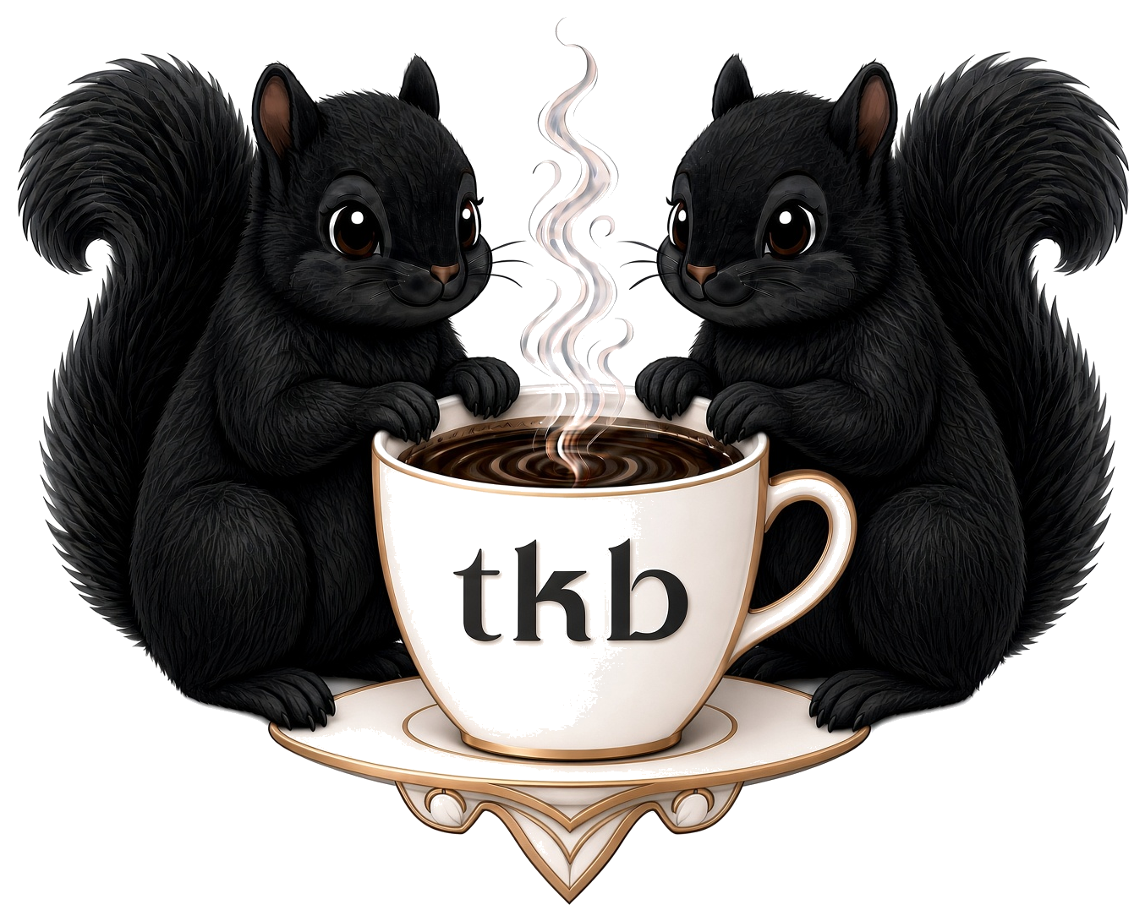
TKB Diner
BREAKFAST · LUNCH · DINNER
Breakfast served all day
814 Broadway · Marysville, KS 66508
(785) 562-3354
Join us on Facebook
Free WiFi · TKB Diner_Guest · password tkb123456
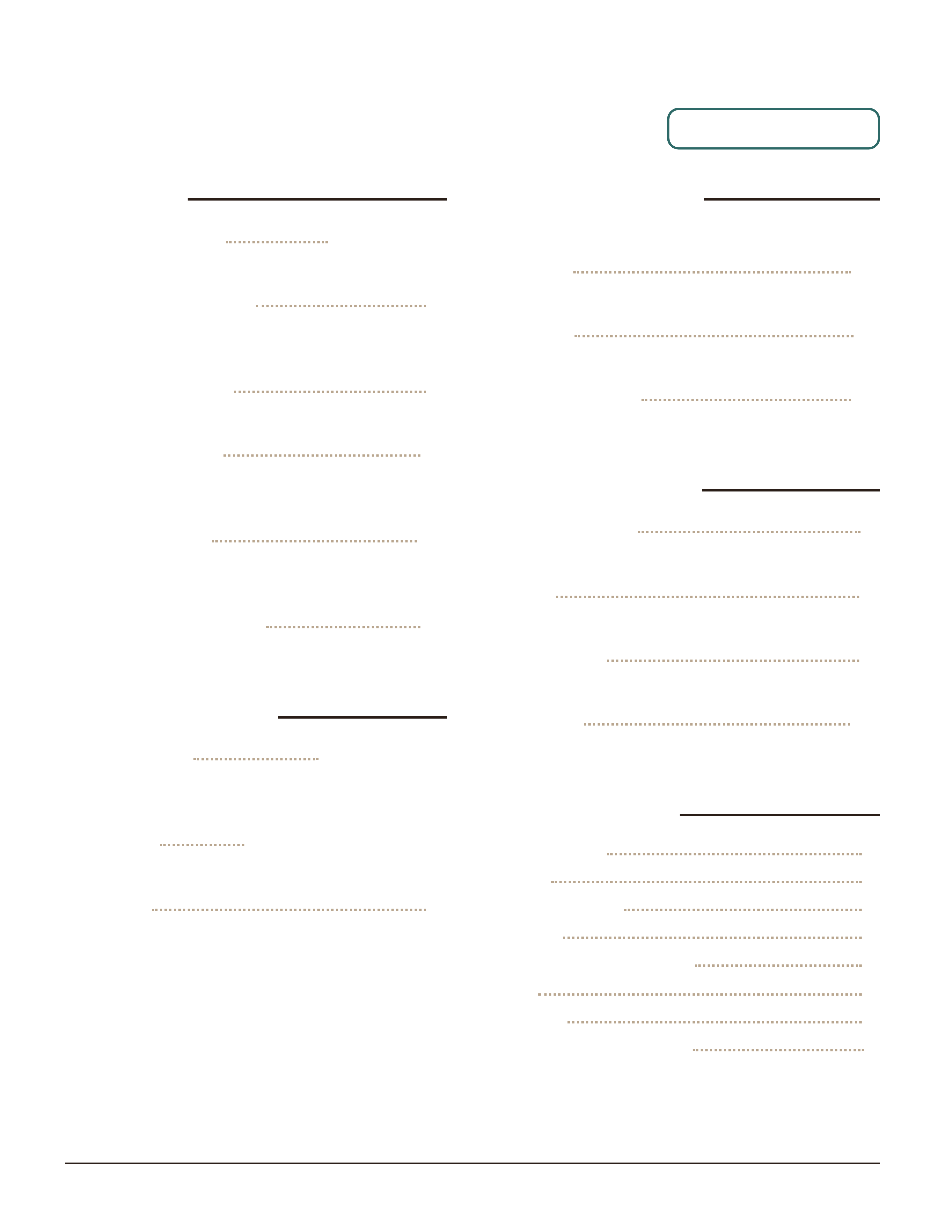
TKB DINER
Classic Breakfast
Favorites
Biscuits & Gravy
Biscuits and homemade sausage gravy
Breakfast Sandwich
Choice of ham, bacon, or sausage, plus cheese and
one egg
Breakfast Burrito
Choice of meat, cheddar, and two eggs
Western Burrito
Ham, cheddar, potatoes, onions, peppers, and two
eggs
Breakfast Bowl
Hashbrowns, ham, bacon, sausage, cheese, veggies,
and two eggs
Stacked Hashbrowns
Ham, bacon, sausage, cheese, veggies, and two eggs
From the Griddle
French Toast
Dusted with powdered sugar, side of syrup · add
blueberries +1
Pancakes
Single, short stack, or full stack
Oatmeal
Served with brown sugar, craisins, and pecans
3-Egg Omelettes
Served with your choice of toast
Denver
Ham, cheddar, onions, and peppers
Garden
All the veggies and cheese
Meat & Cheese
Ham, bacon, or sausage
Breakfast Plates
One Eyed Jack
One egg and toast
Hobo
Two eggs and toast
Bird's Nest
One egg, choice of meat, and toast
Bullseye
Two eggs, choice of meat, and toast
Sides & Extras
Hashbrowns
Toast
Sausage gravy
Biscuit
Ham, bacon, or sausage
Egg
Cheese
Onion, pepper, jalapeño
814 Broadway · Marysville, KS
SERVED ALL DAY
half 4 · full 7
8
9
11
10
11
half 5 · full 10
1 for 2 · 3 for 5 · 6 for 8
6
12
11
12
5
6
9
10
3
3
3
2
4
2
2
1
(785) 562-3354
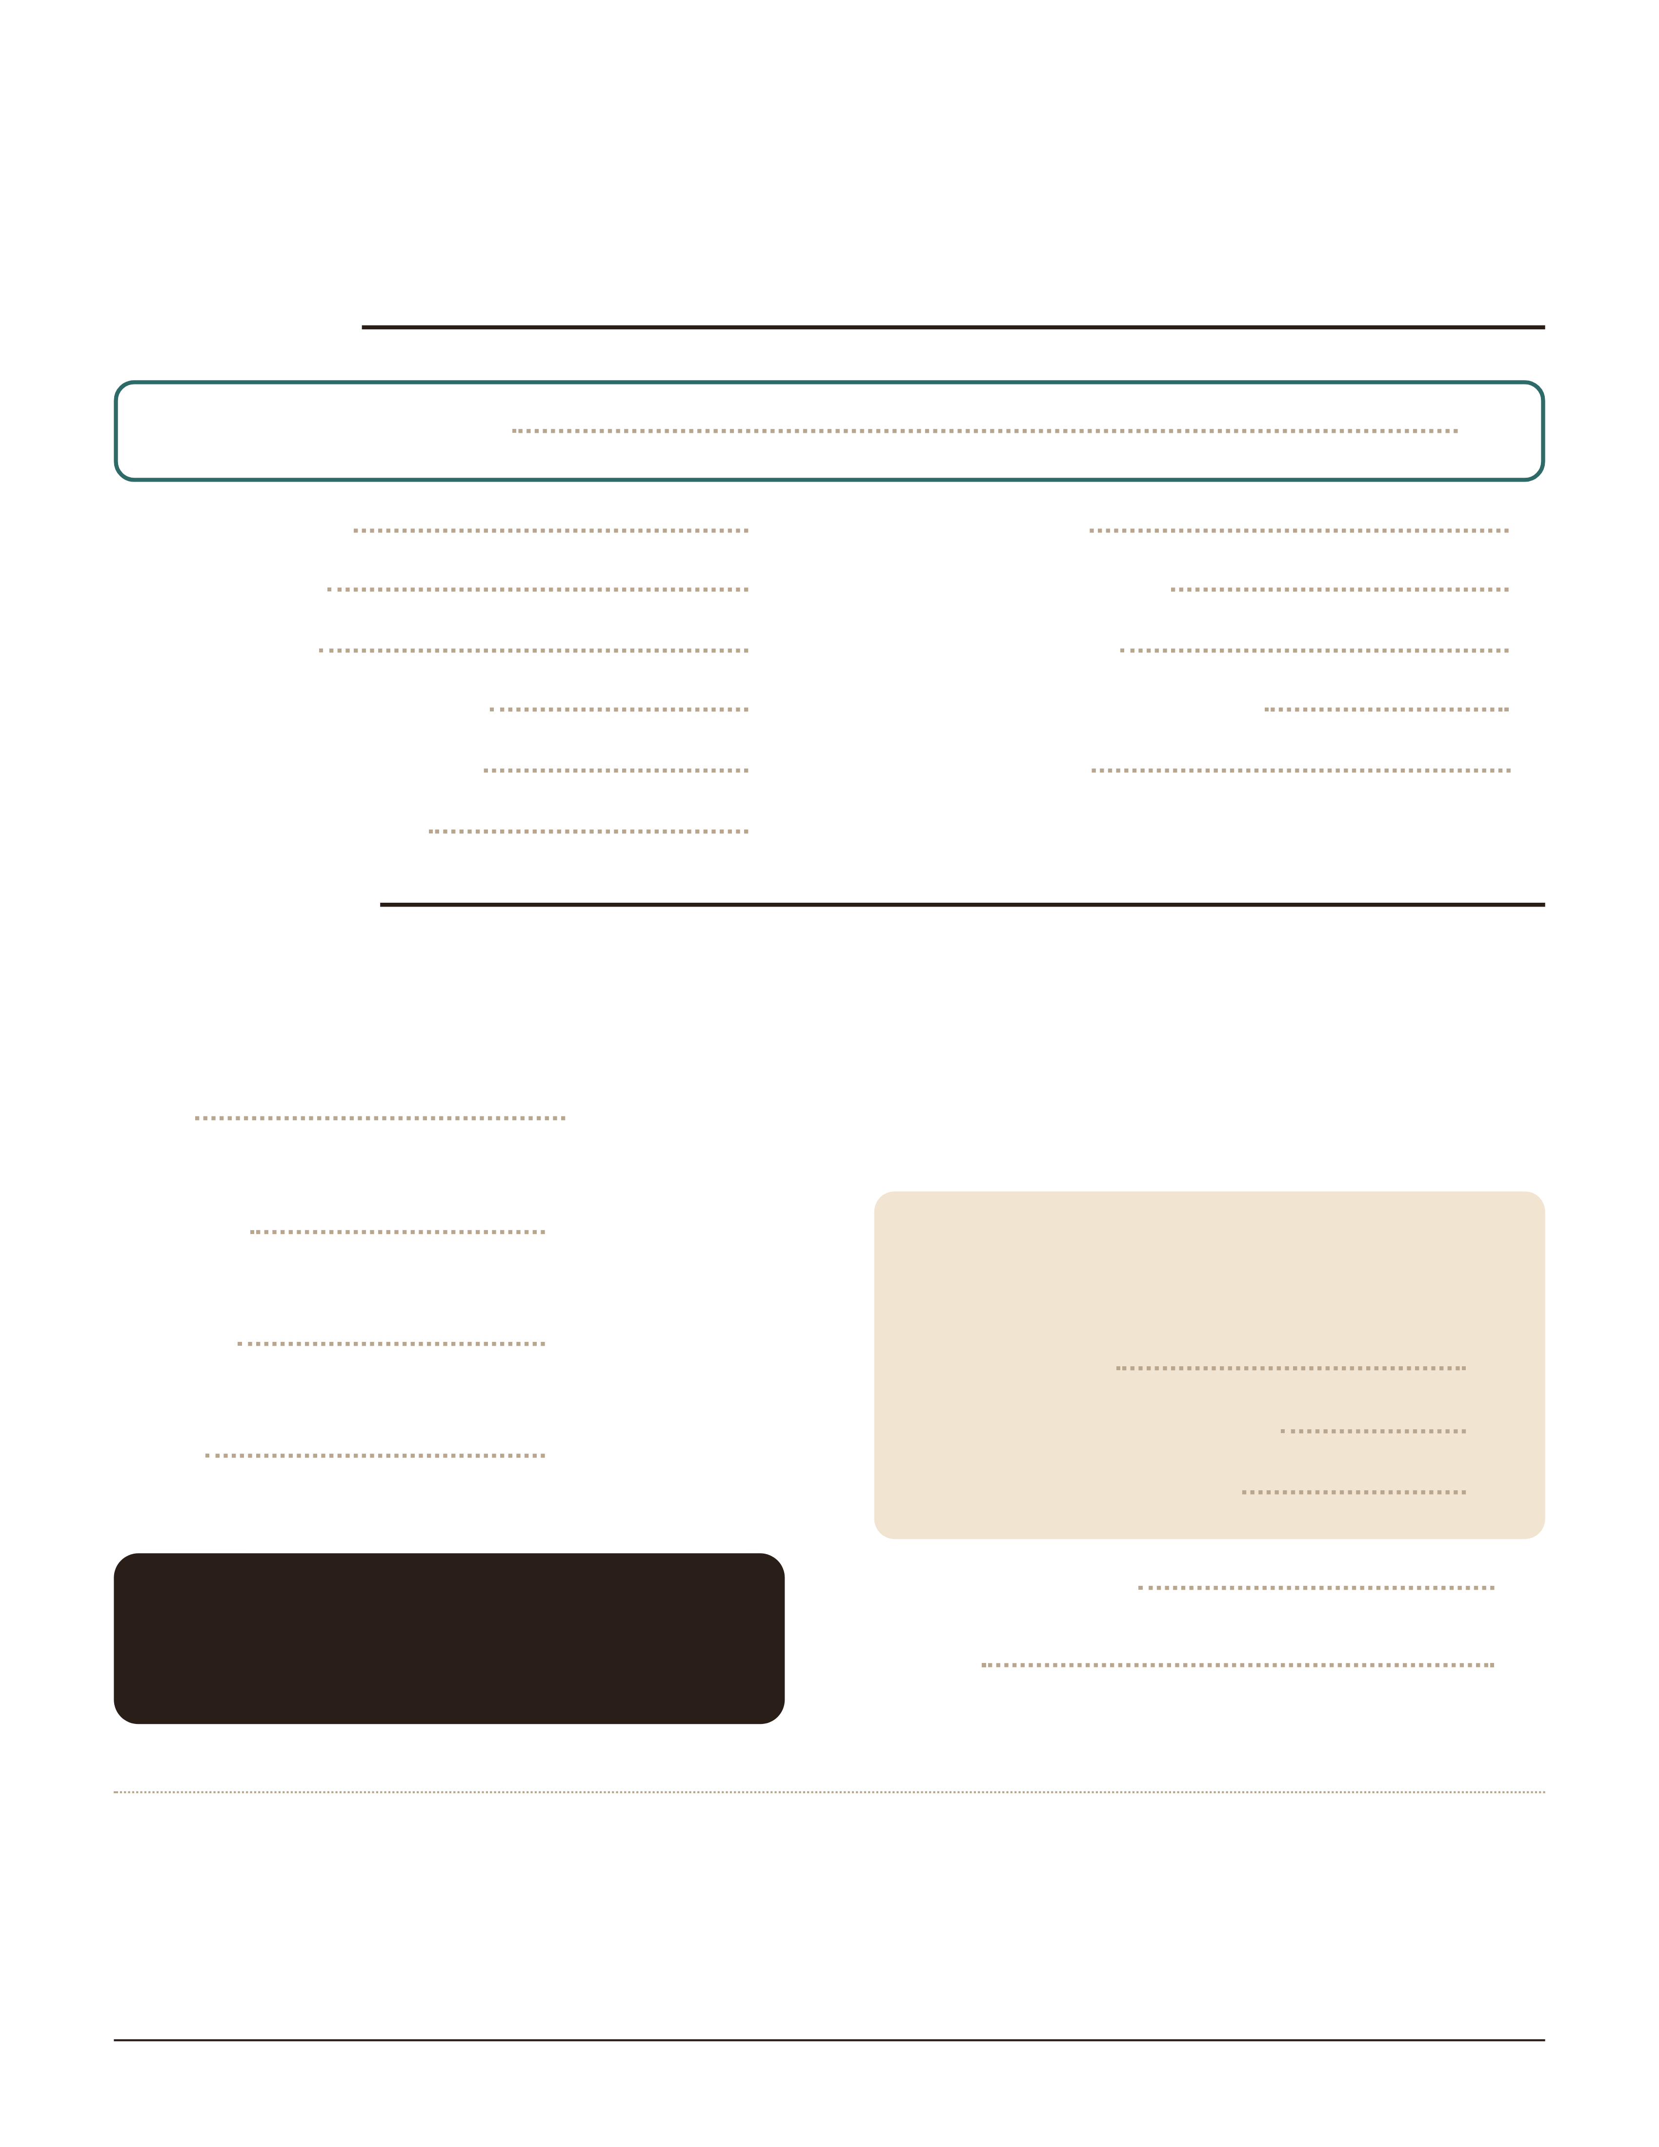
TKB DINER
Appetizers & Sandwiches
Appetizers
Sampler — pick any 3
Corn Nuggets
Onion Rings
Pickle Chips
Mozzarella Sticks
Cheeseballs
Jalapeño Bites
Spinach Artichoke Dip
Broccoli & Cheese Bites
Mac & Cheese Wedges
French Fries
Sweet Potato Fries
Sandwiches
Served with fries · Swap your fries +2: veggie of the day, baked potato, mashed potatoes & gravy, side salad,
seasonal salad, or cup of soup · +4: sweet potato fries or an appetizer · +5: loaded baked potato
DELI CLASSICS
BLT
Wheat, bacon, lettuce, tomato, mayo
Reuben
Rye, corned beef, 1000 Island, sauerkraut, Swiss
Rachel
Rye, turkey, 1000 Island, sauerkraut, Swiss
Club
Sourdough, turkey, bacon, tomato, ranch, Colby jack
WE CATER
Weddings, parties, and meetings
Ask for our catering menu and pricing.
HOT SANDWICHES · 13
On a bun with mayo; lettuce, tomato, and onion on the
side
HAND-BREADED TO ORDER
Breaded by hand in our kitchen and fried crisp
and golden the moment you order.
Pork Tender
Chicken Fried Chicken
Country Fried Steak
Grilled Chicken
Philly
Hoagie bun, peppers, onions, Swiss
Allergies & gluten-free: Many items are or can be made gluten-free. Please tell your server about any allergies and we will
accommodate as best we can. Ours is an open-air kitchen, so cross-contact is always a risk.
Consumer advisory: Eggs on our menu can be ordered raw or undercooked. Consuming raw or undercooked meats, poultry,
seafood, shellfish, or eggs may increase your risk of foodborne illness. For more information, see the Kansas Department of
Agriculture website.
814 Broadway · Marysville, KS
13
8
9
8
9
9
9
9
9
9
7
8
half 9 · full 11
half 10 · full 12
half 10 · full 12
half 10 · full 12
13
13
13
13
13
(785) 562-3354
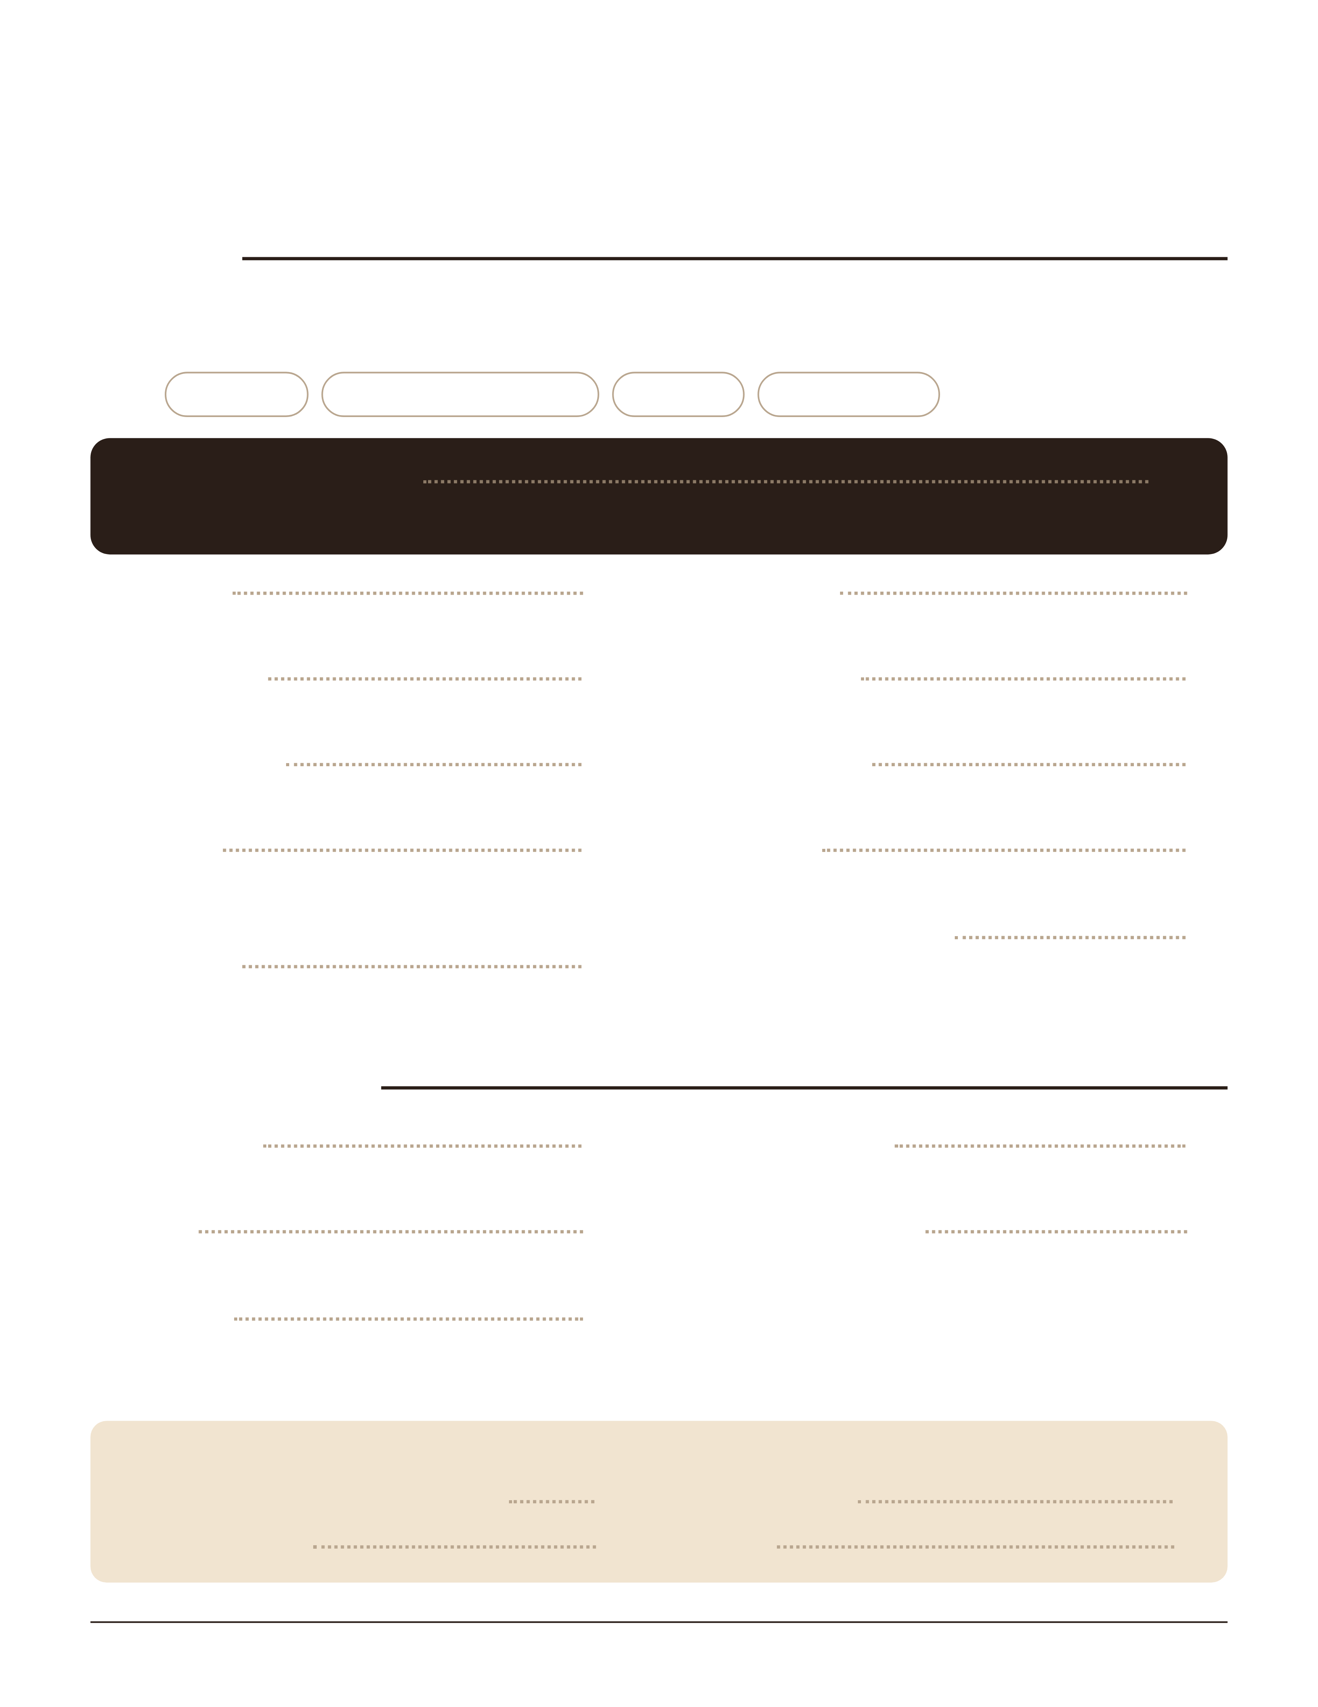
TKB DINER
Burgers, Baskets & Kids
Burgers
Served with fries · Swap your fries +2: veggie of the day, baked potato, mashed potatoes & gravy, side salad,
seasonal salad, or cup of soup · +4: sweet potato fries or an appetizer · +5: loaded baked potato
ADD
Cheese +1
Peppers or jalapeños +1
Bacon +2
Extra patty +3
The Black Squirrel
Bacon jam, muenster & gouda, Nutella
Plain Jane
Just the burger patty
The Whiskey
Swiss, cheddar, bacon, onion tanglers, whiskey sauce
The Firehouse
Pepper jack, bacon, jalapeño, sriracha mayo
TKB Melt
Swiss, grilled peppers, onions and mushrooms, garlic
aioli
The Carter
Cheddar & Swiss, onion tanglers, bacon, fried egg,
ranch
Patty Melt
Rye, 1000 Island, Swiss
The Sunrise
Cheddar, bacon, fried egg
The Midwest
Colby jack, onion ring, BBQ sauce
The Club
Colby jack, turkey, bacon, tomato, ranch
The Reuben Burger
Swiss, corned beef, sauerkraut, 1000 Island
Baskets & Wraps
Fish & Chips
8 oz walleye strips and fries
Shrimp
8 butterfly shrimp and fries
CBR Wrap
Crispy or grilled chicken, bacon, ranch, cheese,
lettuce, tomato
Chicken Strips
Hand-breaded to order · 4 chicken strips and fries
Chicken Nuggets
Hand-breaded to order · 3 chicken strips cut
bite-size, with fries
KIDS' MEALS
Choose fries, mac & cheese, or mashed potatoes
Chicken Strips (2)
hand-breaded
Hamburger
Grilled Cheese
PB&J
814 Broadway · Marysville, KS
14
12
14
14
14
14
13
14
14
14
14
14
15
12
14
12
8
9
7
7
(785) 562-3354
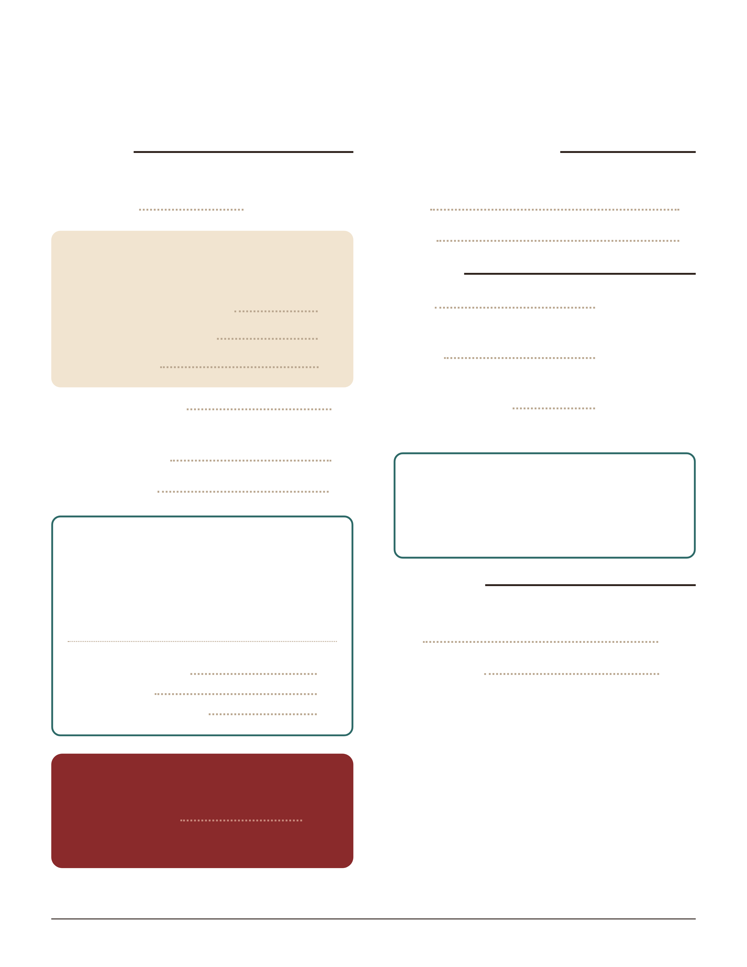
TKB DINER
Entrees, Salads & Desserts
Entrees
Served with your choice of two sides and a dinner roll
Steak Bites
HAND-BREADED TO ORDER
Never pre-breaded: each one is breaded by hand
and fried golden when you order.
Chicken Fried Chicken
Country Fried Steak
Pork Tender
Hamburger Steak
Sautéed mushrooms and onions optional
Grilled Chicken
12 oz KC Strip
SIDES
Choose two with any entree
Fries
Veggie of the day
Baked potato
Mac & cheese
Side salad
Cup of soup
Mashed potatoes & gravy
PREMIUM SIDES
Sweet potato fries
An appetizer
Loaded baked potato
LAST FRIDAY & SATURDAY OF THE
MONTH
Prime Rib
With two sides and a dinner roll
Homemade Soup
Today's soups are posted on the specials board
Cup
Bowl
Salads
Chef
Ham, turkey, tomatoes, cheddar, hard-boiled egg
Greek
Spinach, chicken, olives
Grilled Chicken
Grilled chicken breast
DRESSINGS
Homemade ranch · Blue cheese · Raspberry
vinaigrette · Dorothy Lynch · Italian · 1000
Island · Honey mustard
Desserts
Ask about today's homemade desserts
Pie
Cheesecake
814 Broadway · Marysville, KS
½ lb 18 · 1 lb 23
18
19
17
17
17
26
+2
+2
+3
26
4
6
half 9 · full 12
half 9 · full 12
half 9 · full 12
4.25
4.75
(785) 562-3354
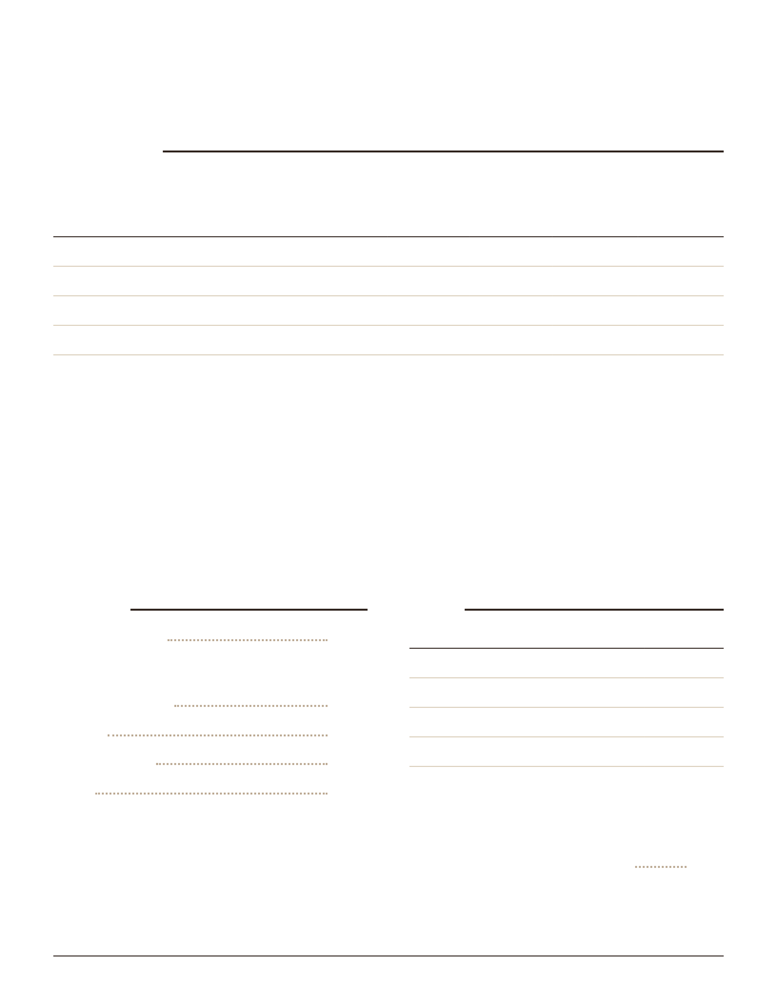
TKB DINER
Coffee Bar & Drinks
Coffee Bar
Make it your way: ask for a Build Your Drink card
3 add-ins included · extras +1.25 each
SIZE
Latte or macchiato · hot or iced
Frappe · blended
Shaken espresso
Cold brew iced coffee
SPECIALTY DRINKS
Any drink below, any size, same price
Apple Pie apple, brown sugar cinnamon, and vanilla
Black Squirrel chocolate, hazelnut, and almond
Blonde white chocolate, caramel, and toasted
marshmallow
Blueberry Pie blueberry, brown sugar cinnamon,
and vanilla
Caramel Kiss caramel and French vanilla
Fluffernutter peanut butter and toasted
marshmallow
Honeybee honey, rose or lavender, and vanilla
London Fog Earl Grey tea, vanilla, lavender, and
steamed milk
Nutty Monkey caramel, banana, and peanut butter
Peppermint Patty chocolate and peppermint
Turtle chocolate, caramel, and toffee
Drinks
Fountain soda
24 oz with unlimited refills · Pepsi, Diet Pepsi,
Mountain Dew, Dr Pepper, Starry
Tea, iced or hot
Coffee
Orange juice
Milk
Water
Beer
BEER
Domestic
Import
Domestic bucket of 6
Import bucket
Domestic: Miller Lite, Bud, Bud Light, Busch Light,
Michelob Ultra, Coors, Coors Light, Yuengling Lager ·
Import: Corona, Heineken, Modelo · Make any beer a
red beer +0.25
Mike's Hard Lemonade, Smirnoff
814 Broadway · Marysville, KS
12 OZ
16 OZ
20 OZ
32 OZ
4.75
5.25
5.75
7.00
—
5.00
5.75
6.75
—
4.00
4.50
5.00
—
3.00
3.25
4.00
3.00
2.50
2.50
3.00
3.00
CAN
BOTTLE
3.00
3.50
3.75
4.00
15.00
17.50
21.00
4.00
(785) 562-3354

